Topics

C - Topics

1 - Data types
2 - Array
3 - Pointers
4 - array to pointer
5 - pointer to array
6 - storage classes
7 - Keyword (volatile imp)
8 - structures / union /pragma
9 - constant pointer
10 - pointer to constant
11 - function pointer
12 - strings
13 - Bitwise
14 - Bitwise operations
15 - operators , expressions
16 - Numeric conversion
17 - loops
18 - files
19 - preprocessor directives
20 - macro
21 - dynamic memory
22 - typedef
23 - compilation stages.
24 - optimizers
25 - increment operators.

Datastructures

1 - sorting
2 - searching
3 - linked list
->single
->double
->circular
4 - tress / graphs
5 - stack
6 - queue
7 - priority queue

Linux -
-->Operating system
1 - Memory mapping
2 - Virtual memory concept
3 - system call
4 - paging , page on demand .
5 - process,
6 - creation(fork , Vfork)
7 - Termination.
8 - PCB , TCB .
9 - COW mechanism
10 - execution types
12 - CPU block
13 - kernel subsystems
14 - signals
15 - Interprocess communication(api's)
->pipes
->message queue
->shared memory
16 - posix
17 - threads
18 - mutex
19 - semaphores

-->Networking
->DNS
->DHCP
->terminologies
->osi model
->layer to layer explanation
->header format of TCP , UDP , IPV4 , Ethernet.
->ARP , icmp , igmp.
->3 way handshake
->socket

BT Topics -
Bredr -
-->usage , why we use it and intro.
1 - Scanning , inquiring , paging , connection
2 - Packets used , packet format ,
3 - LMP Procedure
4 - Security
5 - L2CAP , HCI
7 - Gap
8 - HFP
9 - A2DP
10 - SDP
11 - Total connection to travel from on device to another device ..

BLE -
-->Advertising
-->scanning
-->connection
-->advertising packets ,Pdu , packet format .
-->link layer
-->Gatt
-->Att , gap.
-->security.

C programming
Tuesday, July 9, 2024
4:00 PM

Memory Layout ::

- Stack ->main , array , local variables .
- Heap -> dynamic memory allocation space
- Data
  - .bss -> uninitialized global data
  - .data ->Initiliazed global data

- Text
  - .ro data ->
  - .text - >

Storage classes
Tuesday, July 16, 2024
6:52 PM

The proper use of storage classes makes our program efficient and fast.

Syntax ...
storage class datatype variable name;

There are four types of storage classes
Automatic ::

the variables declared inside a. block/function without any storage class specifier are called automatic variables.
Once the variable is used with in a function or a block it will referred as auto if u don’t mention auto also , the scope of the variable will be with the block or function ..

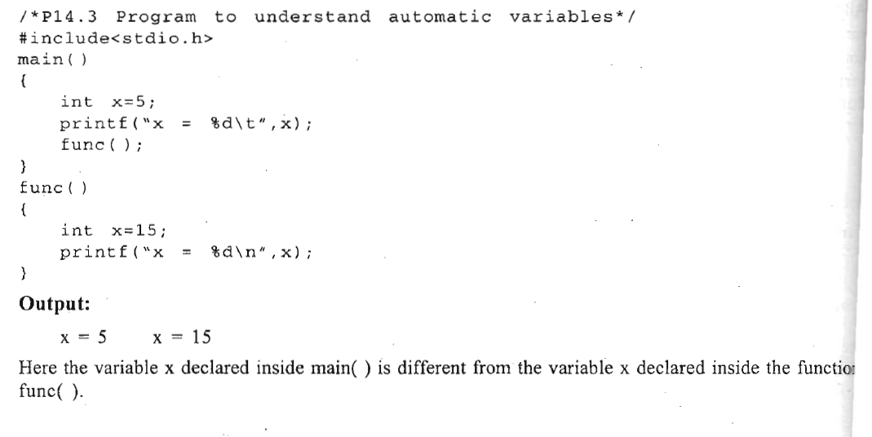

External ::

variables that have to be used by many functions and different files can be declared as external
variabIes. The initial value of an uninitialized external variable is zero.

Definition ::
)Definition creates the variable, so memory is allocated at the time of definition.
) There can be only one definition.
) The variable can be initialized with the definition and initializer should be constant.
) The keyword extern is not specified in the definition. Some compilers may allow the use of extern
but it is better to omit this. keyword in the definition.
) The definition can be written only outside functions

Declaration::
)The declaration does not create the variable, it only refers to a variable that has already been created
somewhere, so memory is not allocated at the time of declaration.
)There can be many declarations.
)The variable cannot be initialized at the time of declaration.
)The keyword extern is always specified in the declaration.
)The declaration can be placed inside functions also.

Static::

There are two types. of static variables- .
(l) Local static variables - the life time of that variable will be throughout the program , it will be like auto but the lifetime of variable will not end after function or block…
(2) Global static variables - The variable decleared here will have the life time untill termination of program , but if we use static in global u cannt access that variable in different files using extern..

Register::

Register storage class can be applied only to local variables. The scope, lifetime and initial value of register variables are same as that of automatic variables. The only difference between the two is in the place where they are stored. Automatic variables are stored in memory while register variables are stored in CPU registers

Linkage::
There are 3 types of linkage
1 - External
2 - Internal
3 - No Linkage

Constant ::

If any variable is declared with const qualifier, then the value of that variable can't be changed by the program. The const qualifier can occur in the declaration before or after the data type.

Different constant in pointer declarations :
1 - Pointer to const data
2 - Const pointer
3 - Const pointer to const data

const pointer in C
<data type> * const <pointer name> = <memory address>;

Pointer to const data in c
const <data type> * <pointer name> = &<constant variable name>;
OR
<data type> const * <pointer name> = &<constant variable name>;

Const pointer to const data in c
const <data type> * const <pointer name> = &<constant variable name>;
OR
<data type> const * const <pointer name> = &<constant variable name>;

Storage classes :
  - auto
  - register
  - static
  - Extern
  - AUTO:
    - Scope: Local to the function/block in which it is declared.
    - Lifetime: Exists during the execution of the block or function.
    - Default: All local variables are auto by default if no other storage class is specified.
    - Visibility: Only accessible within the block or function.
    - Memory: Stored in the stack.
Default value -- garbage value no initialization
  - Register :
    - Scope: Local to the function/block in which it is declared.
    - Lifetime: Exists during the execution of the block or function.
    - Visibility: Only accessible within the block or function.
    - Memory: Suggests to the compiler to store the variable in a CPU register (if available) instead of memory for faster access. However, it's not guaranteed, and the compiler may ignore it.
Default value -- garbage value no initialization
  - Extern :
    - Scope: Global to the entire program. Used to declare variables or functions that are defined in other files (or elsewhere in the same file) outside the current scope.
    - Lifetime: Exists throughout the lifetime of the program.
    - Visibility: Used to access variables and functions from other files (linkage across multiple files)
    - Memory - file where its accessing using extern will not take the memory , the declaration in another file take the memory.
  - Static :
    - Scope: Local or global, depending on where it is declared. If declared in a function, its scope is limited to that function, but it retains its value between function calls. If declared globally, the variable or function is visible only within the file (internal linkage).
    - Lifetime: Exists throughout the lifetime of the program, even if it is inside a function. The variable retains its value between function calls.
    - Visibility:
      - If used within a function, it is visible only within the function, but persists between calls.
      - If used globally, it is visible only in the file where it is declared, making it inaccessible to other files.

C in depth
Tuesday, September 24, 2024
10:23 PM

Introduction to C:
------------------------------------------------------------------------------------------------------------------------------------------------------------
Programming language 1 - Low level & High level language
--> Low Level -- Machine level language & Assembly language
-->High level language -- English

Translators :
1 - Assembler
2 - Compiler
3 -Interpreter

Assembler is used for converting the code of low-level language (assembly language) into machine level
language.

Compilers and interpreters are used to convert the code of high-level language into machine language.
The high level program is known as source program and the corresponding machine language program
is known as object program.

Structure of c programming :
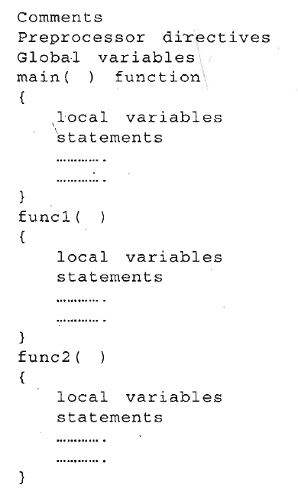

------------------------------------------------------------------------------------------------------------------------------------------------------------
Elements of c:
------------------------------------------------------------------------------------------------------------------------------------------------------------
These basic elements are character set, variables,
datatypes, constants, keywords (reserved words), variable declaration, expressions, statements
C character set used in c ::
1 - alphabets A -Z , a - z
2 -Digits 0 - 9
3 - special characters
4 - Escape sequence /a /b /n /0 -->practise code
5 - Trigraph -->used to print some symbols
6 - Delimiters
->colon
->semicolon
->parentheses
->square brackets
->curly braces
->hash
->comma
7 - Keyword -->coding on all 32 key words
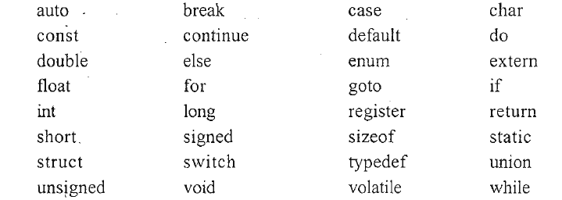

8 - Identifiers
Keywords are defined and can't be changed by the user, while identifiers are user defined words and are used to
give names to entities like variables, arrays, functions, structures etc.

9 - Data Types
->int
->char
->float
->double
-->Qualifiers
-> Size qualifiers - long , short
-> Sign qualifiers - signed , unsigned

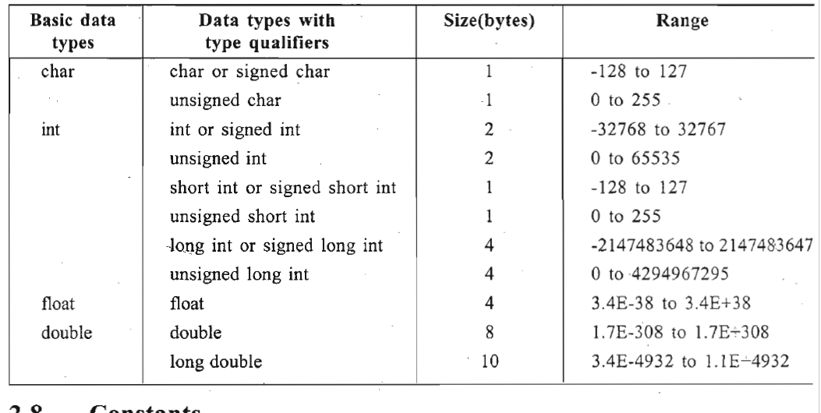

10 - constants
Constant is a vll1ue that cannot be changed during execution of the program.
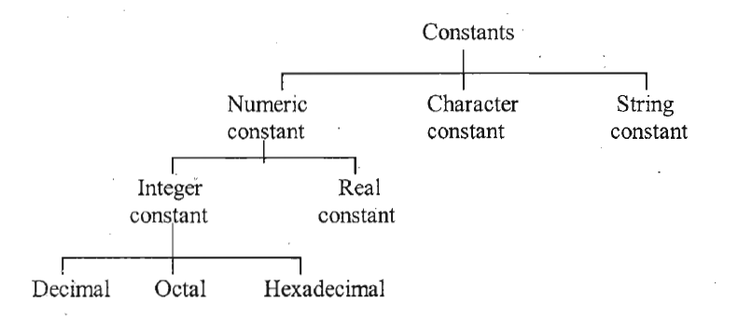

11 - Symbolic constant
A symbolic constant is a name that substitutes for a sequence of characters. The characters may represent
a numeric constant, a character constant or a string constant. Eg :: PI = 3.141592653589793

12 - Variable
Variable is a name that can be -used to store values. Variables can take different values but one at a
time. These values can b~ changed during execution of the program
A data type is associated with
each variable. The data type of the variable decides what values it can take

------------------------------------------------------------------------------------------------------------------------------------------------------------
INPUT OUTPUT IN C
------------------------------------------------------------------------------------------------------------------------------------------------------------
1 - Reading Input Data
->scanf - through this we can scan the data that u want to take from the user
->we can take data to one variable or 2 variables or more ,
2 - Writing Output Data
->Printf - Prints the data from the memory to the terminal.
3 - Formatted input and output
->Format for Integer input
->format for integer output
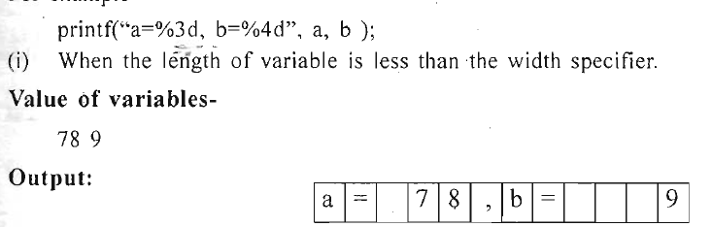
->Formatt for float point input
->Formatt for float point output
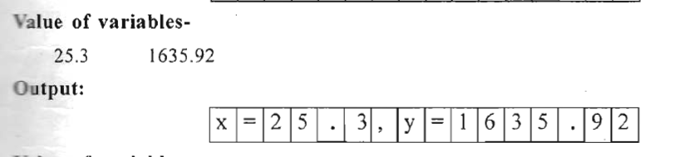

->formatt for string input and output

4 - Suppression character in scanf
->use * in the scanf with % if u want to avoid storing data in particular variable

5 - Character I/O
->getchar()
->putchar()
Takes single character and prints single character

function pointer
Wednesday, December 25, 2024
12:52 PM
1. What is a function pointer?

C compilations
Saturday, April 19, 2025
12:11 PM

Absolutely, I'd be happy to help you understand the compilation process in C and how to check it on Ubuntu!
Compilation Process in C
- Preprocessing: The preprocessor handles directives like #include and #define. It generates a pure C code file without any preprocessor directives.
- Compilation: The compiler translates the preprocessed code into assembly language.
- Assembly: The assembler converts the assembly code into machine code, generating an object file (.o or .obj).
- Linking: The linker combines object files and libraries to produce the final executable.
Checking the Compilation Process in Ubuntu
- Install GCC: Ensure you have the GNU Compiler Collection (GCC) installed. You can install it using:
Copy the codesudo apt update
sudo apt install gcc
- Write Your C Program: Create a C file, for example, hello.c:
Copy the code#include <stdio.h>
int main() {
printf("Hello, World!\n");
return 0;
}
- Compile the Program: Use GCC to compile your program:
Copy the codegcc -o hello hello.c
- Run the Executable: Execute the compiled program:
Copy the code./hello
- Check Each Stage:
  - Preprocessing:
Copy the codegcc -E hello.c -o hello.i
  - Compilation:
Copy the codegcc -S hello.i -o hello.s
  - Assembly:
Copy the codegcc -c hello.s -o hello.o
  - Linking:
Copy the codegcc hello.o -o hello
- View Intermediate Files: You can open and inspect the intermediate files (hello.i, hello.s, hello.o) to understand each stage of the compilation process.
By following these steps, you can compile a C program and check each stage of the compilation process on Ubuntu.

